SIMATS ENGINEERING
ASSESSMENT TOOL 1
COURSE NAME:Database Management Systems
COURSE CODE:CSA05

COURSE OUTCOME COVERED

CO2: Apply the relational model, relational algebra, SQL query structures, and views to solve database querying and data manipulation problems. (BL3, BL6)

Activity Tool : Analytical Problem Solving (High)
Assessment Tool Weightage: 40%

QUESTIONS
Q.No | Question | Bloom's Level
1 | Given a set of relations and sample data, write SQL queries to retrieve specific information using joins and subqueries, and explain the logic used. Bloom’s Level: BL3 – Apply | BL4 – Analyze
2 | Using relational algebra, formulate expressions to solve complex queries such as retrieving records that satisfy multiple conditions across relations.  Bloom’s Level: BL4 – Analyse | BL5 – Evaluate
3 | Given a real-world scenario (e.g., banking or student system), design a relational schema and construct appropriate SQL queries for data retrieval and updates. Bloom’s Level: BL6 – Create | BL6 – Create
4 | Analyse a given SQL query with nested subqueries and predict its output, explaining each step of execution. Bloom’s Level: BL4 – Analyze | BL6 – Create
5 | Compare different SQL approaches (joins vs subqueries) for solving the same problem and evaluate their efficiency. Bloom’s Level: BL5 – Evaluate | BL4 – Analyze
6 | Design and implement views for a database system to provide restricted data access, and justify their use for security and abstraction.  Bloom’s Level: BL6 – Create | BL5 – Evaluate
7 | Given a database schema, write relational algebra expressions and convert them into equivalent SQL queries, analyzing differences in representation.  Bloom’s Level: BL4 – Analyze | BL4 – Analyze
8 | Optimize a set of inefficient SQL queries by restructuring them using joins, indexing concepts, or views, and evaluate performance improvements.  Bloom’s Level: BL5 – Evaluate | BL5 – Evaluate
9 | Develop a complex SQL query involving grouping, aggregation, and nested queries to solve a real-world problem.  Bloom’s Level: BL6 – Create | BL6 – Create
10 | Given multiple relations, analyze the query requirements and decide whether to use views, joins, or subqueries, justifying your choice with reasoning.  Bloom’s Level: BL5 – Evaluate | BL5 – Evaluate

Code of Conduct:

I THARUN KUMAR(192571017) certify that this submission is my original work and that I have adhered to the guidelines specified for this assessment.
I understand that any violation of academic integrity rules will result in disciplinary action.

Signature of the student:


RUBRICS FOR CALCULATION:

Criteria | Level 4 (Exemplary) | Level 3 (Proficient) | Level 2 (Developing) | Level 1 (Beginning)
Problem Understanding | Clearly interprets problem, identifies all parameters and requirements accurately | Understands problem with minor gaps | Partial understanding; misses key elements | Misinterprets or unable to understand problem
Method Selection | Selects most appropriate method/formula with strong justification | Selects correct method with minor errors | Inappropriate or partially correct method | Unable to select method
Solution Process | Logical, systematic steps with correct approach throughout | Mostly correct steps with minor mistakes | Disorganized steps; multiple errors | No clear process
Accuracy of Calculation | All calculations accurate; correct final answer | Minor calculation errors | Frequent errors; incorrect final answer | No valid calculations
Interpretation of Results | Clearly interprets results with units and engineering relevance | Basic interpretation with minor omissions | Limited or unclear interpretation | No interpretation

Q1. Retrieve specific information using SQL queries:
SELECT * FROM Student
WHERE Marks > 80;

Using a Subquery:
SELECT Name, Marks
FROM Student
WHERE Marks >
(
SELECT AVG(Marks)
FROM Student
);

OUTPUT:
Logic:
- The subquery calculates the average marks.
- The outer query displays students whose marks are above the average.
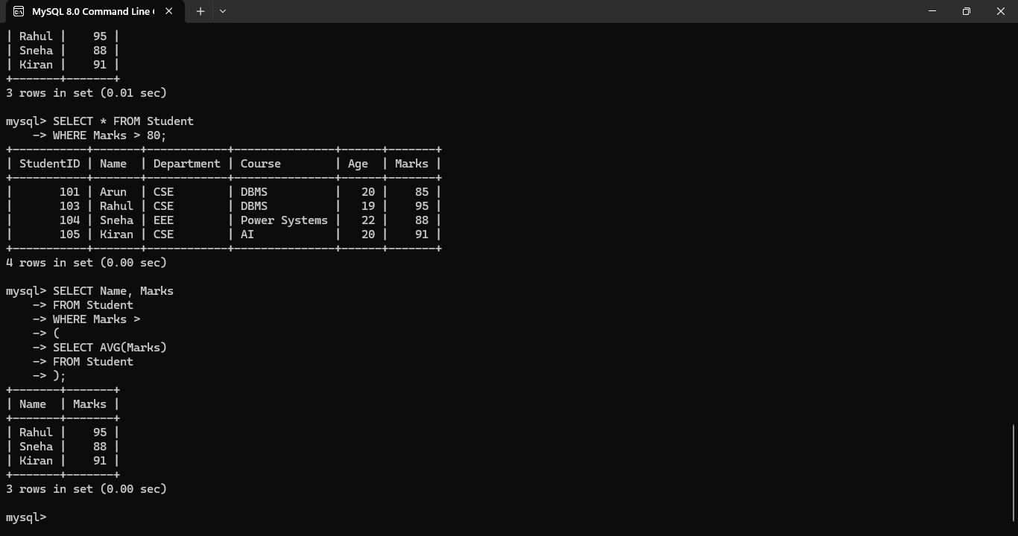
Q2. Relational Algebra
$$π_{Name}\left(σ_{Department=^{'}CSE^{'}∧Marks>80}\left(Student\right)\right)$$
Equivalent SQL:
SELECT Name
FROM Student
WHERE Department='CSE'
AND Marks>80;

OUTPUT:
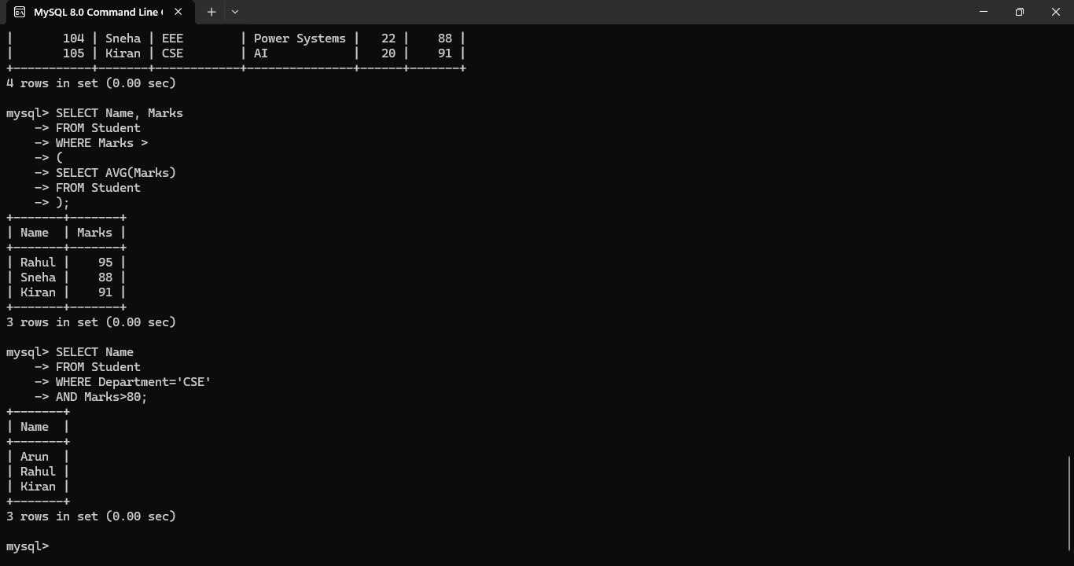

Q3. Real-world schema and SQL queries

Schema
CREATE TABLE Student (
StudentID INT PRIMARY KEY,
Name VARCHAR(30),
Department VARCHAR(20),
Course VARCHAR(30),
Age INT,
Marks INT
);

OUTPUT:
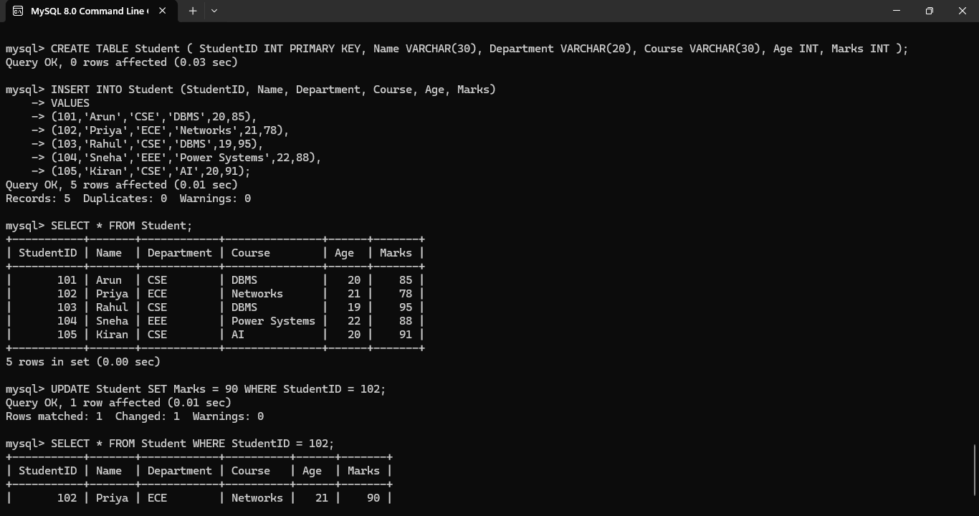

Q4. Analyse a Given SQL Query with Nested Subqueries and Predict Its Output

SQL Query
SELECT Name
FROM Student
WHERE Marks =
(
SELECT MAX(Marks)
FROM Student
);

Execute the Inner Query
SELECT MAX(Marks)
FROM Student;

OUTPUT:
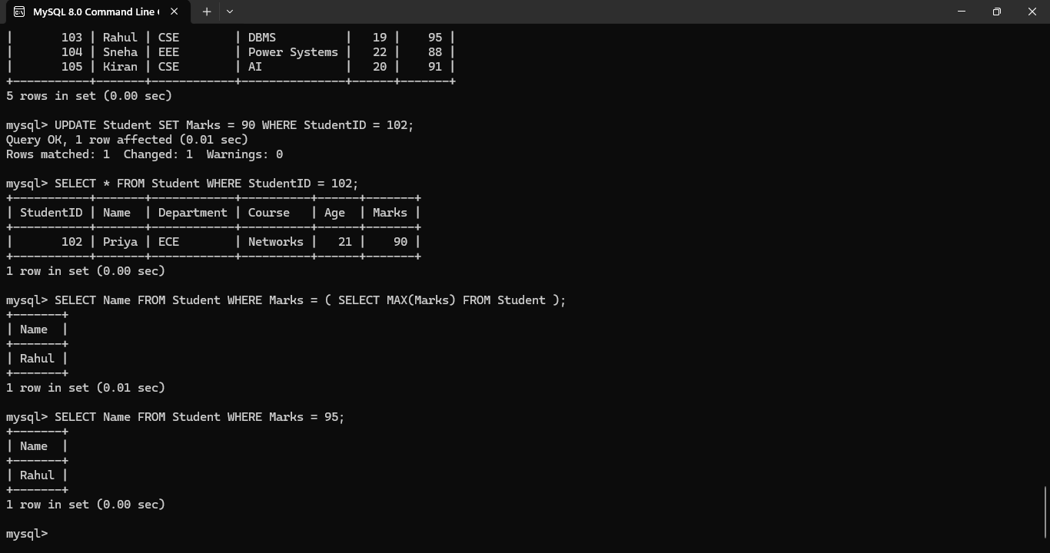

Q5. Compare Different SQL Approaches (Joins vs Subqueries) for Solving the Same Problem and Evaluate Their Efficiency

Approach 1: Using a Subquery
SELECT StudentID, Name, Marks
FROM Student
WHERE Marks >
(
SELECT AVG(Marks)
FROM Student
);

OUTPUT: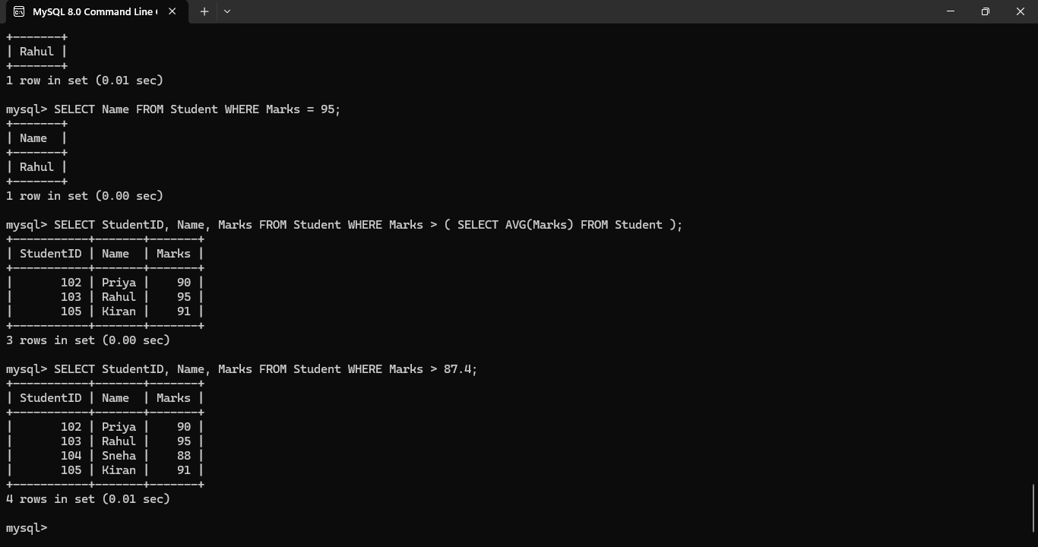

Q6. Design and Implement Views for a Database System to Provide Restricted Data Access, and Justify Their Use

Create a View
The following view displays only the student's ID, Name, Department, and Marks while hiding other details such as Course and Age.
CREATE VIEW StudentView AS
SELECT StudentID, Name, Department, Marks
FROM Student;

Display the View
SELECT * FROM StudentView;

OUTPUT:
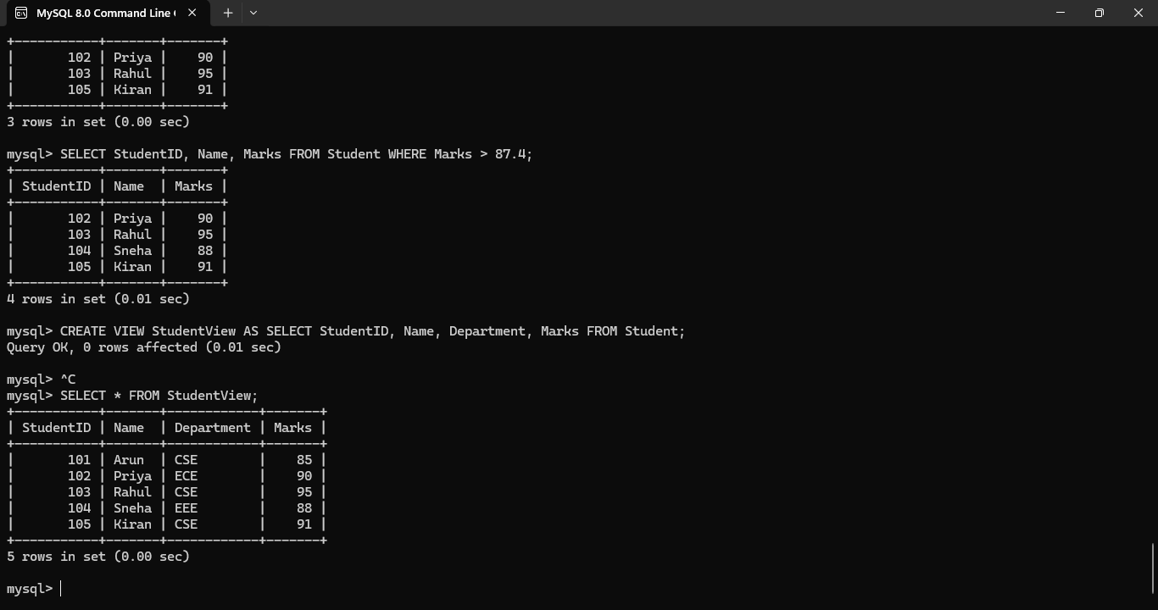
Q7. Given a Database Schema, Write Relational Algebra Expressions and Convert Them into Equivalent SQL Queries, Analyzing Differences in Representation

Relational Algebra Expression
[
\pi_{Name}\left(\sigma_{Marks>90}(Student)\right)
]
Explanation:
- σ (Selection): Selects students whose Marks > 90.
- π (Projection): Displays only the Name column.

Equivalent SQL Query
SELECT Name
FROM Student
WHERE Marks > 90;

OUTPUT:
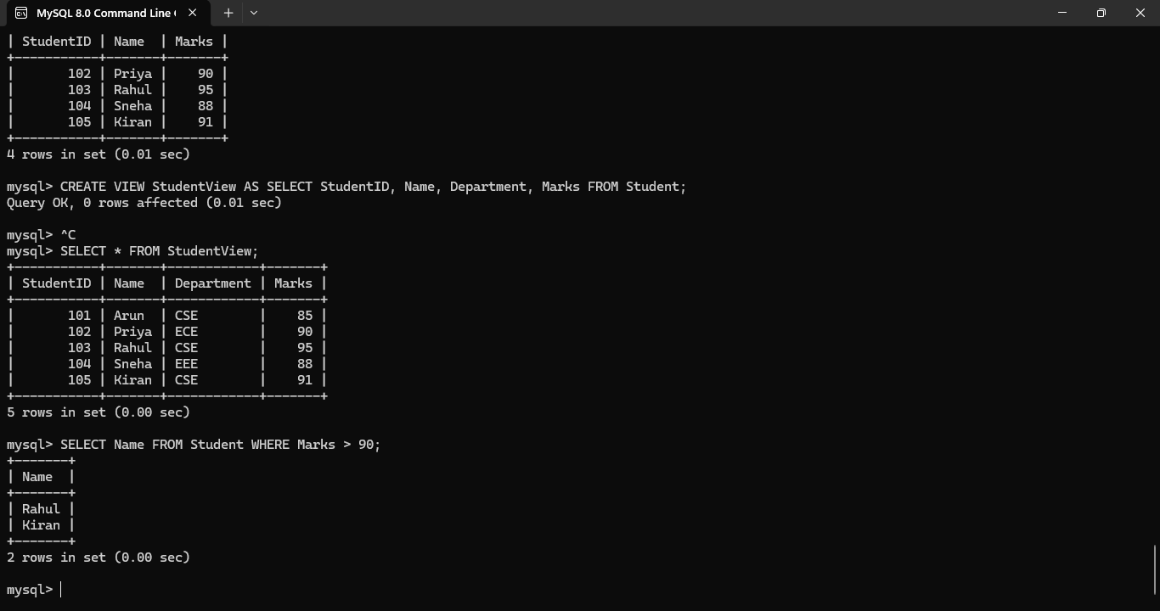
Q8. Optimize a Set of Inefficient SQL Queries by Restructuring Them Using Indexing Concepts or Views, and Evaluate Performance Improvements

Inefficient Query
The following query retrieves all columns, even though only the student's name and marks are required.
SELECT *
FROM Student
WHERE Marks > 80;

Optimized Query
Retrieve only the required columns.
SELECT Name, Marks
FROM Student
WHERE Marks > 80;

OUTPUT:

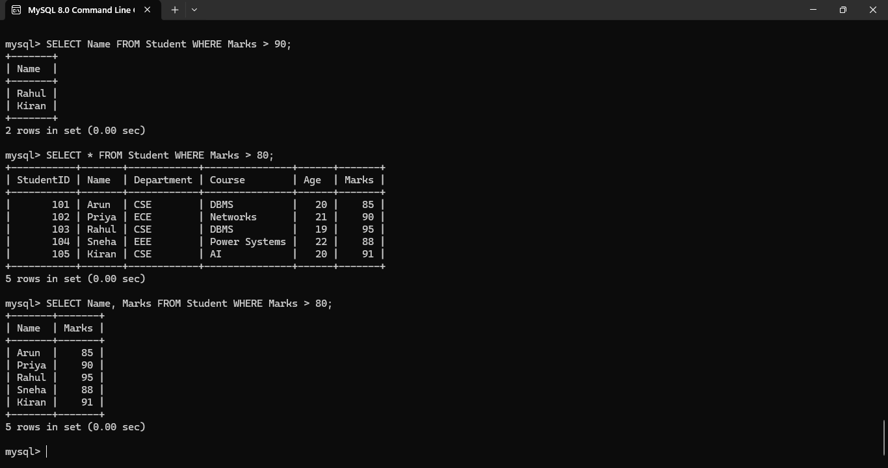

Q9. Develop a Complex SQL Query Involving Grouping, Aggregation, and Nested Queries to Solve a Real-World Problem

SQL Query
S
ELECT Department, AVG(Marks) AS AverageMarks
FROM Student
GROUP BY Department
HAVING AVG(Marks) >
(
SELECT AVG(Marks)
FROM Student
);

SELECT AVG(Marks)
FROM Student;

OUTPUT:
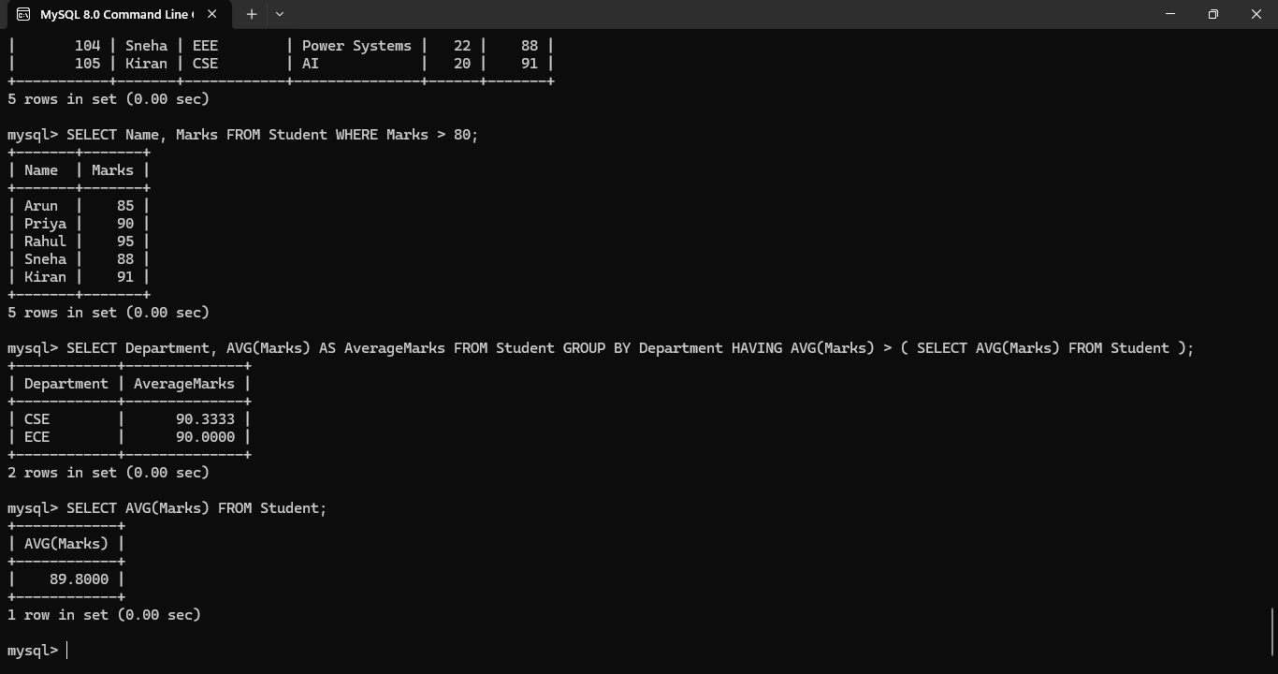

Q10. Given Multiple Query Requirements, Decide Whether to Use Views, Joins, or Subqueries and Justify Your Choice

Requirement 1: Display only Student ID, Name, Department, and Marks
CREATE VIEW StudentView AS
SELECT StudentID, Name, Department, Marks
FROM Student;

Requirement 2: Find Students Who Scored Above the Average Marks
Subquery
SELECT Name, Marks
FROM Student
WHERE Marks >
(
SELECT AVG(Marks)
FROM Student
);

Requirement 3: Combine Data from Multiple Tables
SELECT S.Name, D.DepartmentName
FROM Student S
JOIN Department D
ON S.DepartmentID = D.DepartmentID;

OUTPUT:

